**DAILY ONLINE ACTIVITIES SUMMARY**

|  |  |  |  |  |  |  |  |  |
| --- | --- | --- | --- | --- | --- | --- | --- | --- |
| **Date:** | **27-07-2020** | | | | | **Name:** | **RAVALI P** | |
| **Sem & Sec** | **6 B** | | | | | **USN:** | **4AL17CS076** | |
| **Online Test Summary** | | | | | | | | |
| **Subject** | | **OPERATING SYSTEMS** | | | | | | |
| **Max. Marks** | | **30** | | **Score** | | | **-** | |
| **Certification Course Summary** | | | | | | | | |
| **Course** | **Introduction to HTML5** | | | | | | | |
| **Certificate Provider** | | | **Coursera** | | **Duration** | | | **12 hrs** |
| **Coding Challenges** | | | | | | | | |
| **Problem Statement:** Python Program for Smallest K digit number divisible by X | | | | | | | | |
| **Status: COMPLETED** | | | | | | | | |
| **Uploaded the report in Github** | | | | | **YES** | | | |
| **If yes Repository name** | | | | | <https://github.com/Ravalipr/Daily-Status.git> | | | |
| **Uploaded the report in slack** | | | | | **YES** | | | |

Online Test Details:

Online Course Details:

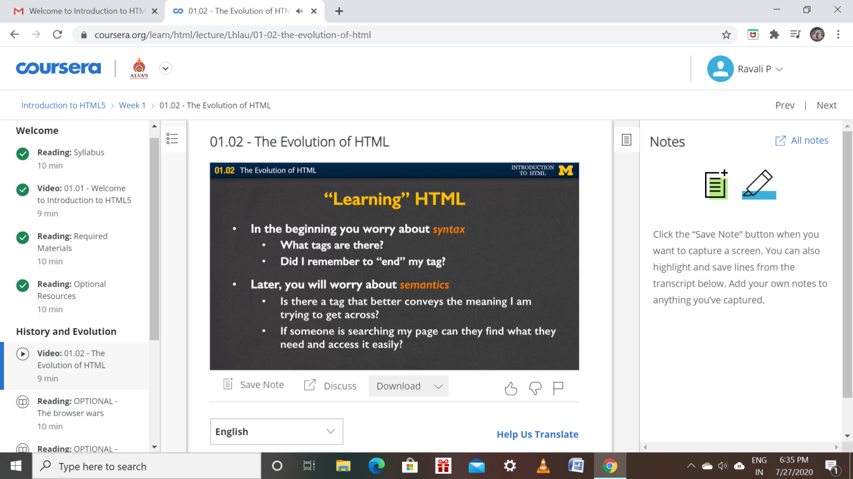

Online Coding Details:

